**Step 1: -** Login to the console and navigate to the server which we need to restore.

**Step 2: -** Copy the Boot-Disk (OS-Disk) name, from which we can able to restore the server.



**Step 3: -** Navigate to snapshot and paste/search the name.

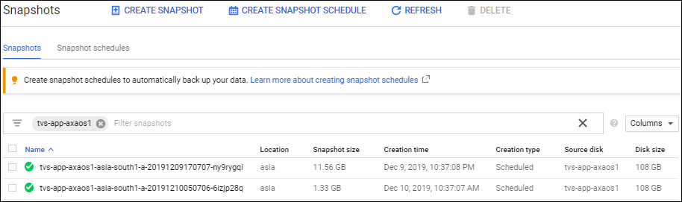

**Step 4: -** Click on the available latest snapshot. From which we can able to restore.

Click on Create Instance.

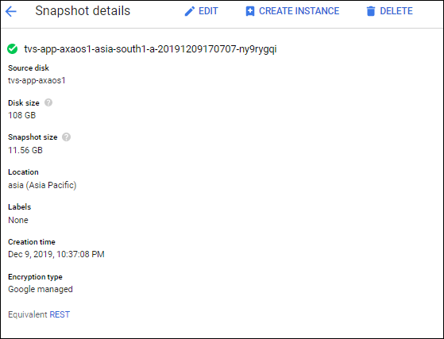

**Step 5: -** Create an Instance with required configuration.

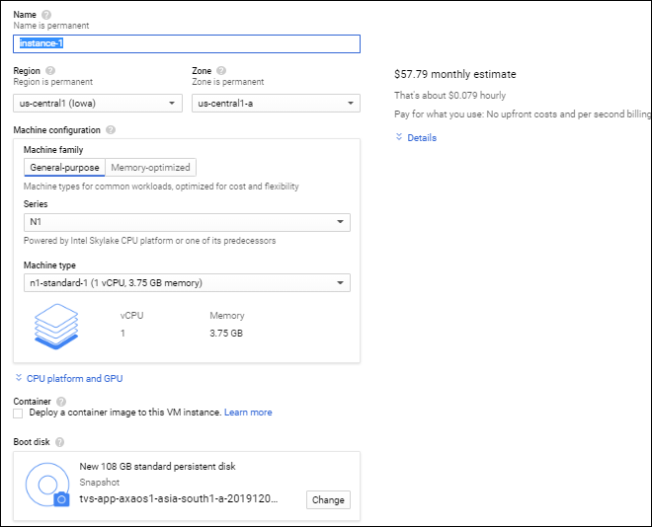

**Step 6: -** Once Instance launched, navigate to the root sever **(from which we have restored the instance).** Copy the available disk name which we need to attach to the restored server.



**Step 7: -** Again navigate to the restored server, click on edit -- move to disk and click on **“Add New Disk”**

**Step 8: -** Select the source as snapshot, and search for the disk name which has been copied earlier and click on save.

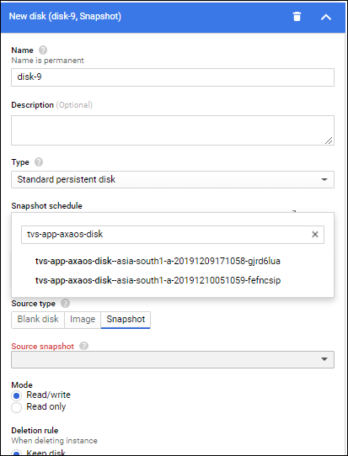

**Step 9: -** Login to the server and check the server the functionality, then attach the disk.

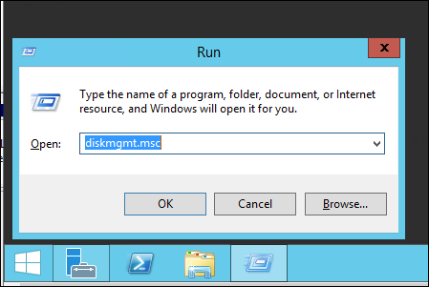

**Step 10: -** Default the disk will be in offline (Click on it and make it as online), and then right click on the disk and click on the “Change Drive Letter and Paths”.

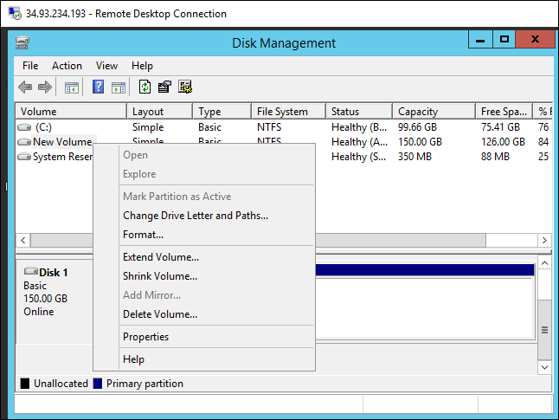

**Step 11: -** Click on Add and add the desired drive name.

Once added check the functionalities of the disk.

